Sprint-4

**Train The Model On IBM**

**Register For IBM Cloud**

|  |  |
| --- | --- |
| Date | 18 Nov 2022 |
| Team ID | PNT2022TMID36166 |
| Project Name | Classification of Arrhythmia by Using Deep Learning with 2-D ECG Spectral Image Representation |

TASK:

Register For IBM Cloud:

LOGIN IN IBM CLOUD(SCREEN SHOT):

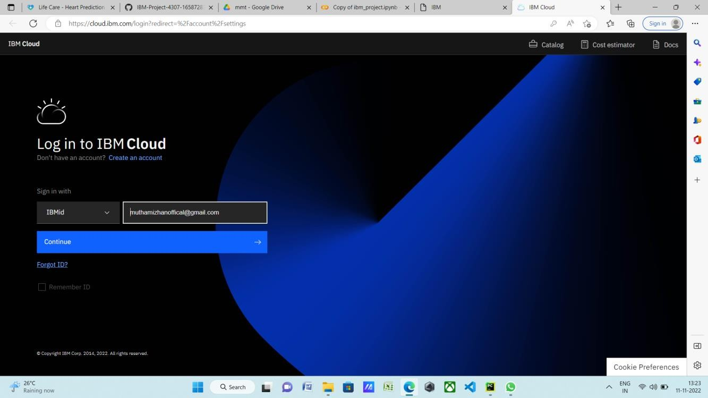

CONFIRM IN PWD (SCREEN SHOT):

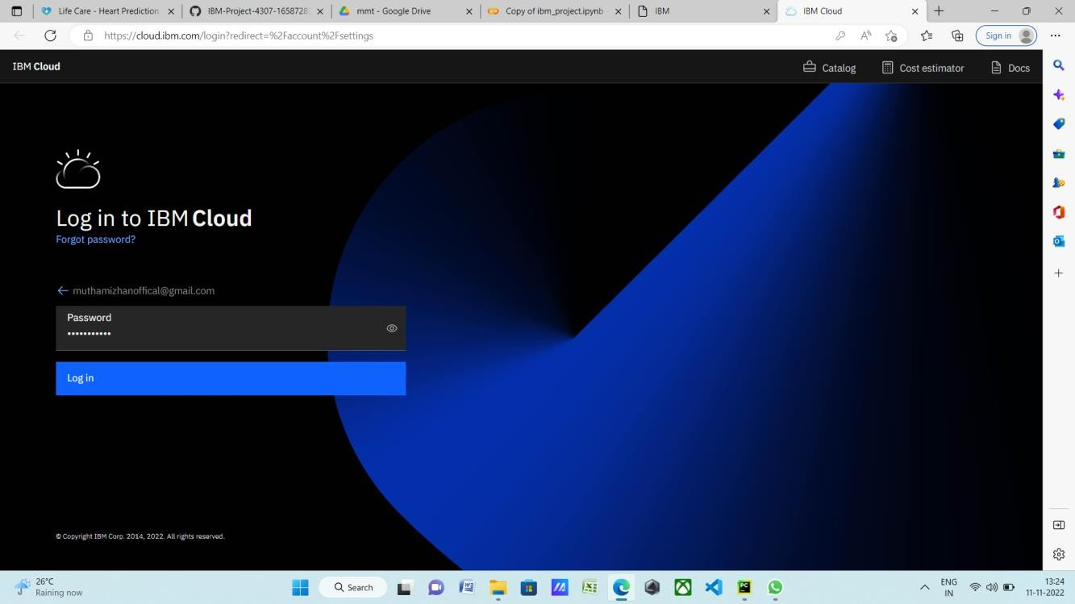

IBM DASHBOARD (SCREEN SHO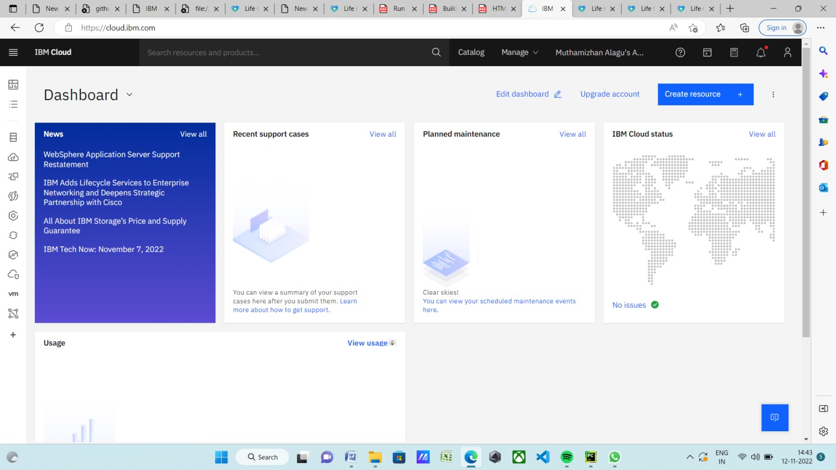T